"Getting to Know Our Neighbors”
Poverty and Homelessness in San Mateo County
Sunday, September 24th at 7:00 p.m.
Crystal Springs UMC: 2145 Bunker Hill Dr., San Mateo
8.4% of San Mateo county residents live in poverty.
Please join us for a panel discussion on poverty and homelessness in San Mateo County. This discussion will address:
- What is being done
- What needs to be done
- How to break the cycle
- Our biggest challenges
- What San Mateo County is doing right
- How you can help
We are excited to bring together leaders from the following charitable organizations who are working to address poverty and homelessness in San Mateo County:
Lynnelle Bilsey, Senior Manager Volunteer Programs
www.lifemoves.org
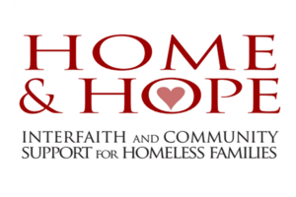 | Meg Clark, Executive Director  www.homeandhope.net
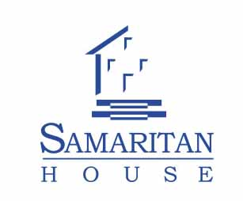 | Bart Charlow, Chief Executive Officer  www.samaritanhousesanmateo.org
*Any donations collected during the event will be divided equally among the 3 organizations represented. Checks should be made payable to "CSUMC" or "Crystal Springs United Methodist Church" with the designation "Poverty Panel Donation." You may also donate directly to the organizations via their websites.

