Music Sunday Service
at Crystal Springs UMC
May 20th at 10:00 a.m.
2145 Bunker Hill Dr., San Mateo

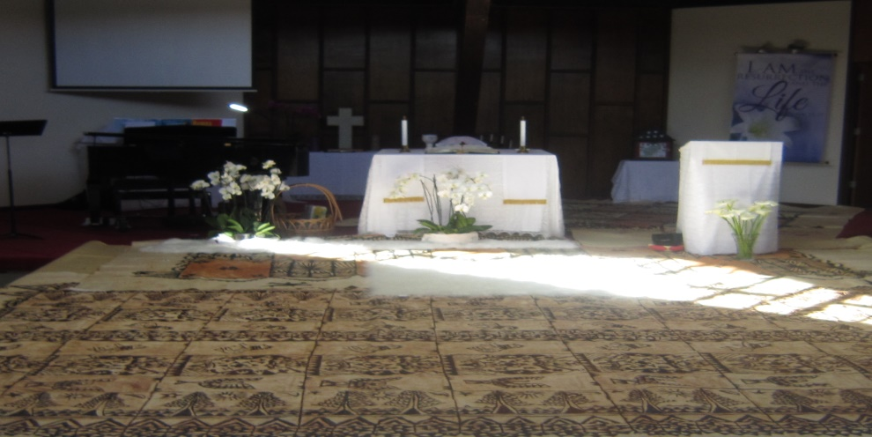

Musicians:

James Dunning - Trumpet
Gale Edwards - Flute
Abhaya Krishnan-Jha - Soprano
Diane Musgrave - Piano
Jonathan Wing - Piano

CSUMC Adult Choir
Bill Alley, Music Director

